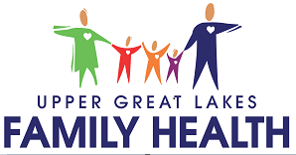

Patient Household Information Survey – 2026
Collecting information about your household size and income allows Upper Great Lakes Family Health Center to receive grant funding to help keep health care costs lower, offer reduced fees by up to 80% to qualifying individuals and provide high quality health care to everyone in our community regardless of their ability to pay. All UGL patients are asked annually to complete a brief questionnaire about their household size and income. This information is kept confidential and is used only for reporting purposes and further determining each patient’s eligibility for financial assistance.

Income is defined as gifts and total cash receipts such as wages, salaries, public assistance, unemployment, retirement payments, social security, alimony, etc. before taxes. Income does not include non-cash benefits (food stamps, school lunches, or food/rent) in lieu of wages.

A household is defined as all persons who occupy a housing unit whether related to each other or not.

How many people are in your household? ______

(OVER)

